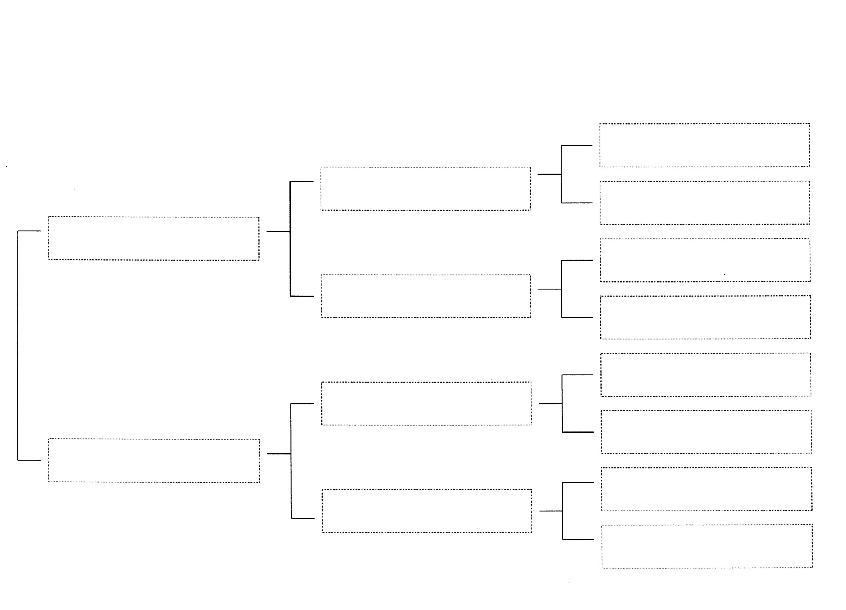

Planned Breeding Month: **November 2022**

Estimated Kidding Month: **April 2023**

Estimated Cost per kid: **Doeling - $250 Buck - $175 Wether: $75**

BLF

Miss Licky

Kyeema Ridge

Moody Blues

Kyeema Ridge

BB Serena

Old Mountain Farm

Pasang

Triple Arrow Farm

Blue Louise

Kyeema Ridge

Laredo

Triple Arrow Farm

Daisey Mae

Zanzabeez

BB Always in Style

Zanzabeez

FF Broke the Mold

Old Mountain Farm

Fat Tuesday

Old Mountain Farm

Sayomis

Zanzabeez

BTM Gucci in Style

Old Mountain Farm

Samurai

Roamn Ranch

S Colt