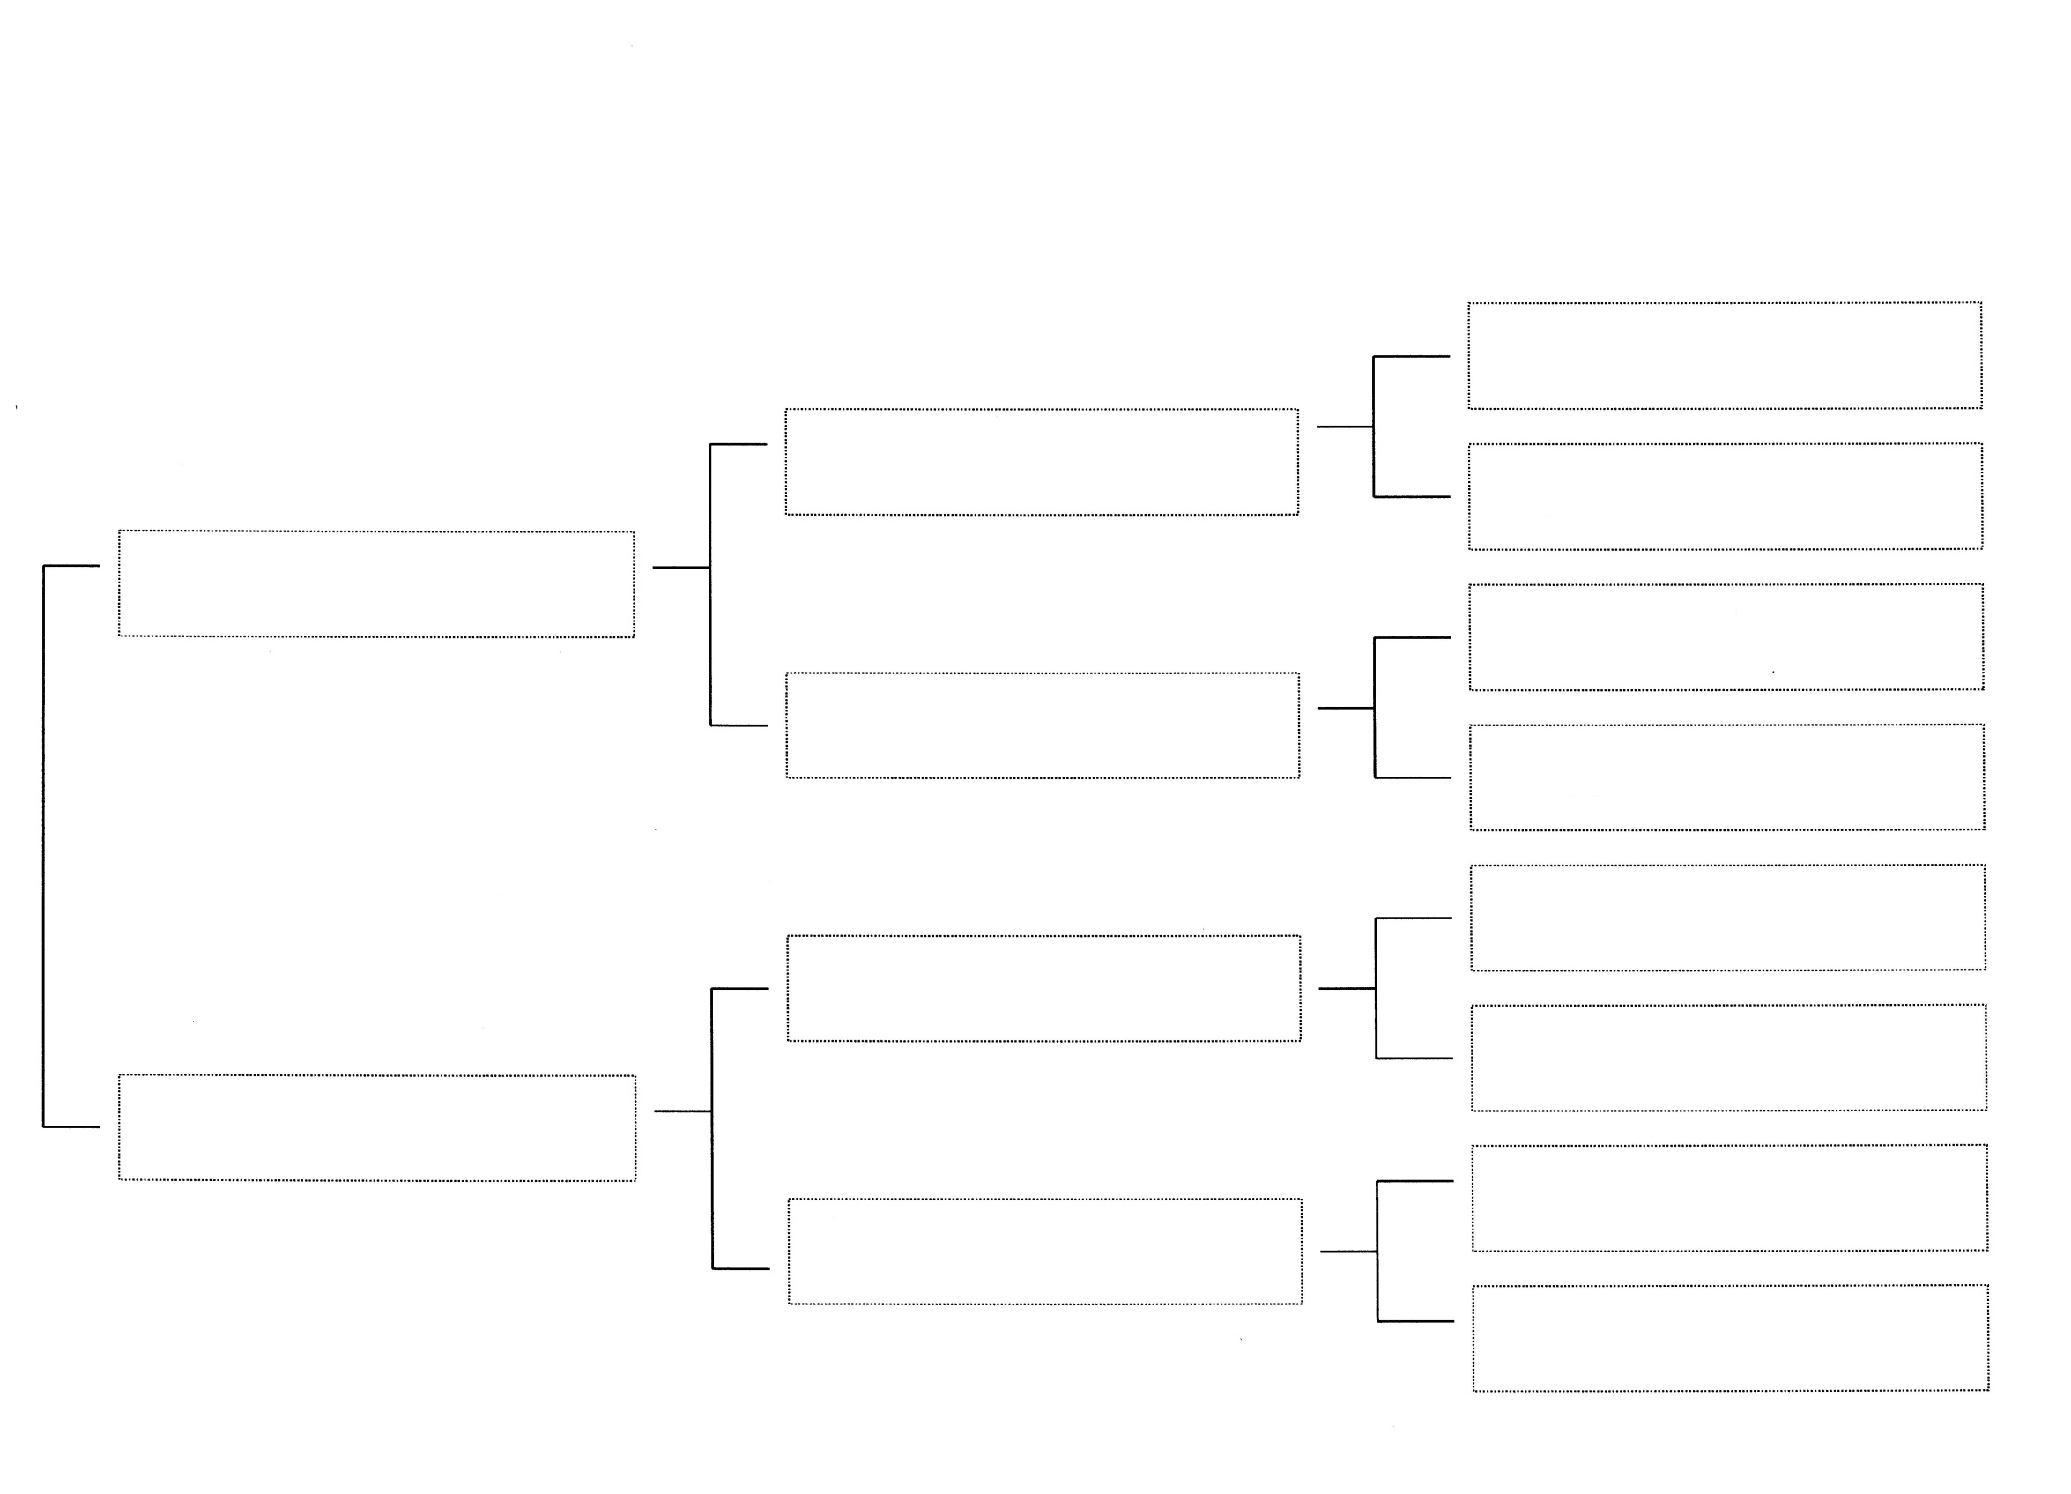
Planned Breeding Month: November 2022
Estimated Kidding Month: April 2023
Estimated Cost per kid: Doeling - $250 Buck - $175 Wether: $75
Zanzabeez
EO Fate’s Melody
Meadowmist Mt
Captain Morgan
The J&K
Astrid
Neverest
DR Prince Charming
My Country Hill
CM Harmony
Black Eagle Ranch
Moon Shadow
Black Eagle Ranch
Moondance (polled)
Zanzabeez
BB Always in Style
Zanzabeez
FF Broke the Mold
Old Mountain Farm
Fat Tuesday
Old Mountain Farm
Sayomis
Zanzabeez
BTM Gucci in Style
Old Mountain Farm
Samurai
Roamn Ranch
S Colt

