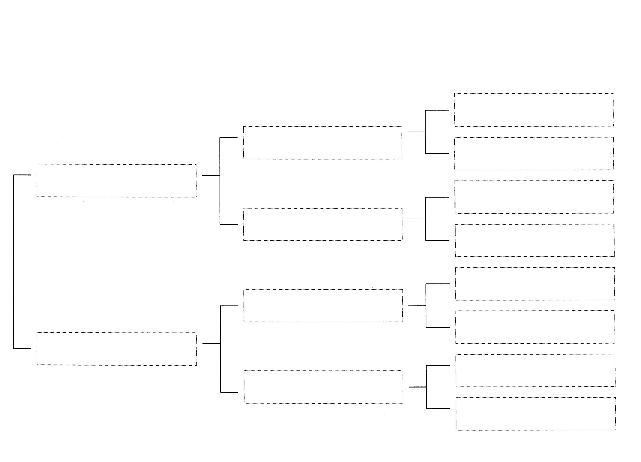
Planned Breeding Month: October 2022
Estimated Kidding Month: March 2023
Estimated Cost per kid: Doeling - $250 Buck - $175 Wether: $75
BLF
Miss Licky
Kyeema Ridge
Moody Blues
Kyeema Ridge
BB Serena
Old Mountain Farm
Pasang
Triple Arrow Farm
Blue Louise
Kyeema Ridge
Laredo
Triple Arrow Farm
Sunshine Rae
Zanzabeez
BB Always in Style
Zanzabeez
FF Broke the Mold
Old Mountain Farm
Fat Tuesday
Old Mountain Farm
Sayomis
Zanzabeez
BTM Gucci in Style
Old Mountain Farm
Samurai
Roamn Ranch
S Colt

